Sum of two Gaussians:

$$K\left(S,T\right)=N_{1}\left(S_{1},T_{1},σ \right)+ N_{2}\left(S_{2},T_{2},σ \right), where N_{i}= \frac{1}{\sqrt{2πσ^{2}}}e^{-[{\left(S-S_{i}\right)}^{2}+{\left(T-T_{i}\right)}^{2}]/(2σ^{2})}$$

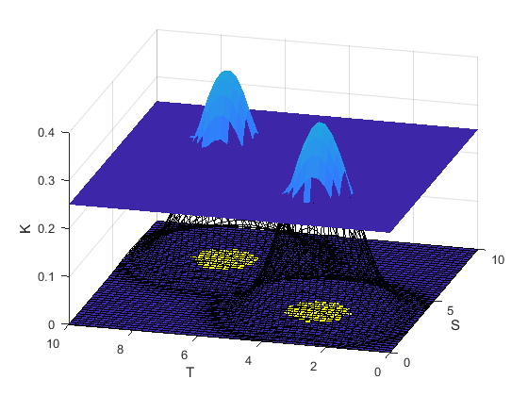

Fig. 1. Surface and Projection of K(S, T)≧0.25, where N1(7, 7, 0.5), N2(3, 3, 0.5).

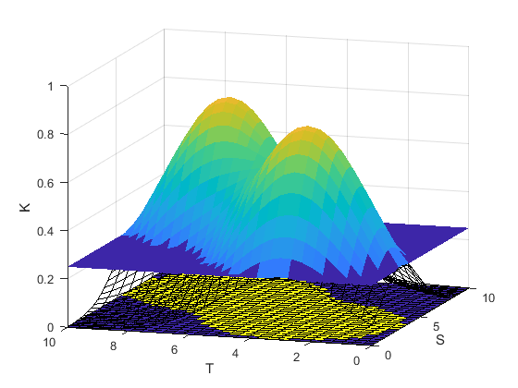 Fig. 2. Surface and Projection of K(S, T)≧0.25, where N1(7, 7, 1), N2(3, 3, 1).

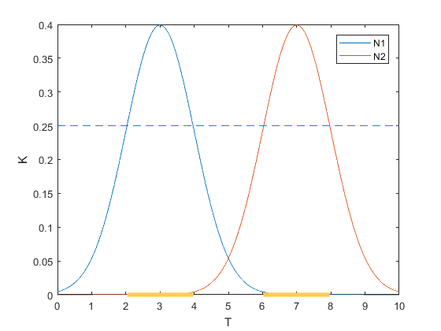

Fig. 3. N1(T1 = 3) & N2(T2 = 7), where σ= 1.

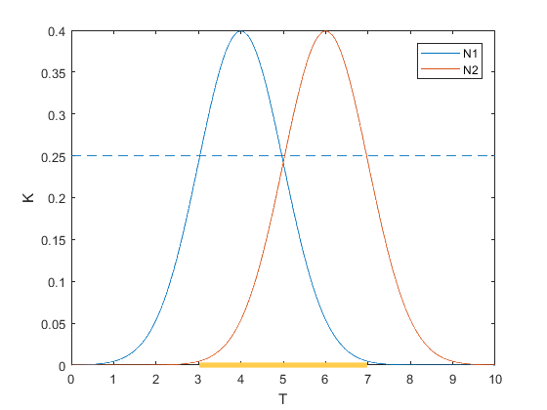

Fig. 4. N1(T1 = 4) & N2(T2 = 6), where σ= 1.